Brave lung disease victim first in UK to have pioneering stem cell treatment

17:32, 2 February 2015 By Euan Stretch

Roisin Kelleher-O’Callaghan, 20, who was born with cystic fibrosis, had been told her only hope was a double lung transplant

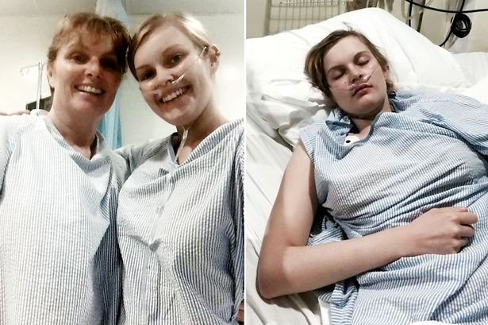
Brave: Roisin and her mum
A young woman is believed to be the first person in the UK to have had pioneering stem cell treatment for a crippling lung condition.
Roisin Kelleher-O’Callaghan, 20, who was born with cystic fibrosis, had been told her only hope was a double lung transplant as her condition deteriorated.
Brave Roisin needed needed oxygen to breath and could only walk a few steps unaided.
But her mum Anntoinette, 49, found out about a pioneering new procedure in the Dominican Republic, yet to be approved here.
And in just three months the family raised £55,000 for the treatment in which she was given stem cells from her mum’s bone marrow.
Roisin, now back home in Faversham, Kent, said:” I can see some improvements already. It is just amazing.”
Anntoinette said: Before she slept 20 hours day, now she can get up herself and even go out to the shops.”
Roisin said: "It will be about six weeks until I feel the full benefit, but I can definitely see some improvements already.
"Going up the stairs still kills me but it takes me less time to get my breath back. And my heart rate is coming down. That is just amazing."
The stem cell treatment heals the damaged lung tissues by mixing healthy cells from the patient's bone marrow and those of a genetic relative who does not have cystic fibrosis, but is a carrier.
Despite her health problems, Roisin has a place at Christchurch University in Canterbury, Kent to study psychology which she hopes to start in September.

